نموذج دراسة الصحة المهنية

Submitter Detail
تفاصيل المرسل
User ID: |  |  | Name: |  |  |  | Contact Number:
الرقم الوظيفي |  |  | الاسم |  |  |  | رقم التواصل
Command: |  |  | Unit: |  | Tarasul No:
القيادة |  |  | الوحدة |  | رقم التراسل

General Details
تفاصيل عامة
Command: |  |  |  | Battalion: |  |  |  | Sub Unit:
الوحدة |  |  |  | الكتيبة |  |  |  | القسم
Assessment Date: |  |  |  |  | Assessment Time: |  |  |  | Previous Assessment Date:
تاريخ التقييم |  |  |  |  | وقت التقييم |  |  |  | تاريخ التقييم السابق
Assessment Team: Role: |  |  |  |  |  | Name: |  |  |  |  |  | ID#: |  |  | Contact #:
فريق التقييم |  |  |  |  |  | الاسم |  |  |  |  |  | الرقم |  |  | رقم التواصل
Assessment Team: Role: |  |  |  |  |  | Name: |  |  |  |  |  | ID#: |  |  | Contact #:
فريق التقييم |  |  |  |  |  | الاسم |  |  |  |  |  | الرقم |  |  | رقم التواصل
Reason for Survey:
سبب اجراء التقييم

Specific Details
تفاصيل معينة
Type of Survey: |  |  |  |  |  |  | Monitoring Device:
نوع التقييم |  |  |  |  |  |  | اسم الجهاز
Emirate: |  |  |  |  | Base/Area: |  |  |  | Location: |  |  |  |  | Building#:
الامارة |  |  |  |  | القاعدة/ المنطقة |  |  |  | الموقع |  |  |  |  | المبنى
Specific Location: |  |  |  |  |  |  | Time From: |  |  |  | Time To:
الموقع المعين |  |  |  |  |  |  | الوقت: من |  |  |  | الوقت: الى
Work Activity Monitored:
مراقبة نشاط العمل

Risk Assessment #:
تقييم المخاطر رقم:
Subtask:
المهمة الفرعية
Existing Controls: |  |  |  | ☐Elimination |  |  |  | ☐Substitution |  |  |  |  |  | ☐Engineering |  |  |  |  | ☐Administrative |  |  |  |  |  |  |  | ☐PPE |  |  | Evaluation:
التدابير المتوفرة حالياً |  |  |  | إزالة |  |  |  | الاستبدال |  |  |  |  |  | التحكم الهندسي |  |  |  |  | التحكم الاداري |  |  |  |  |  |  |  | المعدات الشخصية |  |  | التقييم
Sample Reading: |  |  |  |  |  | Limit: |  |  |  |  |  | Reference: |  |  |  |  |  |  |  | Exceedance? |  |  |  |  |  |  |  |  | Note:
قراءة الجهاز |  |  |  |  |  | المحدودية |  |  |  |  |  | المرجع |  |  |  |  |  |  |  |  | التجاوزات |  |  |  |  |  |  |  | الملاحظة
Hazard & Risk: Category: |  |  |  |  |  |  |  |  | Specific: |  |  |  |  |  |  |  |  | Probability: |  |  |  |  |  |  |  | Severity: |  |  |  |  | Risk:
فئة المخاطرة |  |  |  |  |  |  |  |  | التحديد |  |  |  |  |  |  |  |  | الاحتمالية |  |  |  |  |  |  |  | الشدة |  |  |  |  | المخاطرة
Define New Control: |  |  |  |  |  |  |  |  |  |  | Control Subtype: |  |  |  |  |  |  |  |  |  |  |  |  | Residual Risk: |  |  |  |  | Evaluation:
إيجاد تدابير جديدة |  |  |  |  |  |  |  |  |  | النوع الفرعي للتدابير |  |  |  |  |  |  |  |  |  |  |  |  |  | المخاطر المتبقية |  |  |  |  | التقييم
Control Measure/Action:
الإجراءات التصحيحية
Action Officer: |  |  |  |  |  |  |  |  |  |  |  |  | Status: |  |  | ☐In Process |  |  |  |  |  | ☐Complete |  |  |  |  |  | Follow up Date:
الضابط المخول للعمل |  |  |  |  |  |  |  |  |  |  |  |  | الحالة |  | تحت الاجراء |  |  |  |  |  |  |  | تم الانتهاء |  |  |  |  | تاريخ المتابعة
Risk Assessment #:
Subtask:
المهمة الفرعية
Existing Controls: |  |  |  | ☐Elimination |  |  |  | ☐Substitution |  |  |  |  |  | ☐Engineering |  |  |  |  | ☐Administrative |  |  |  |  |  |  |  | ☐PPE |  |  | Evaluation:
التدابير المتوفرة حالياً |  |  |  | إزالة |  |  |  | الاستبدال |  |  |  |  |  | التحكم الهندسي |  |  |  |  | التحكم الاداري |  |  |  |  |  |  |  | المعدات الشخصية |  |  | التقييم
Sample Reading: |  |  |  |  |  | Limit: |  |  |  |  |  | Reference: |  |  |  |  |  |  |  | Exceedance? |  |  |  |  |  |  |  |  | Note:
قراءة الجهاز |  |  |  |  |  | المحدودية |  |  |  |  |  | المرجع |  |  |  |  |  |  |  |  | التجاوزات |  |  |  |  |  |  |  | الملاحظة
Hazard & Risk: Category: |  |  |  |  |  |  |  |  | Specific: |  |  |  |  |  |  |  |  | Probability: |  |  |  |  |  |  |  | Severity: |  |  |  |  | Risk:
فئة المخاطرة |  |  |  |  |  |  |  |  | التحديد |  |  |  |  |  |  |  |  | الاحتمالية |  |  |  |  |  |  |  | الشدة |  |  |  |  | المخاطرة
Define New Control: |  |  |  |  |  |  |  |  |  |  | Control Subtype: |  |  |  |  |  |  |  |  |  |  |  |  | Residual Risk: |  |  |  |  | Evaluation:
إيجاد تدابير جديدة |  |  |  |  |  |  |  |  |  | النوع الفرعي للتدابير |  |  |  |  |  |  |  |  |  |  |  |  |  | المخاطر المتبقية |  |  |  |  | التقييم
Control Measure/Action:
الإجراءات التصحيحية
Action Officer: |  |  |  |  |  |  |  |  |  |  |  |  | Status: |  |  | ☐In Process |  |  |  |  |  | ☐Complete |  |  |  |  |  | Follow up Date:
الضابط المخول للعمل |  |  |  |  |  |  |  |  |  |  |  |  | الحالة |  | تحت الاجراء |  |  |  |  |  |  |  | تم الانتهاء |  |  |  |  | تاريخ المتابعة

Risk Assessment #:
Subtask:
المهمة الفرعية
Existing Controls: |  |  |  | ☐Elimination |  |  |  | ☐Substitution |  |  |  |  |  | ☐Engineering |  |  |  |  | ☐Administrative |  |  |  |  |  |  |  | ☐PPE |  |  | Evaluation:
التدابير المتوفرة حالياً |  |  |  | إزالة |  |  |  | الاستبدال |  |  |  |  |  | التحكم الهندسي |  |  |  |  | التحكم الاداري |  |  |  |  |  |  |  | المعدات الشخصية |  |  | التقييم
Sample Reading: |  |  |  |  |  | Limit: |  |  |  |  |  | Reference: |  |  |  |  |  |  |  | Exceedance? |  |  |  |  |  |  |  |  | Note:
قراءة الجهاز |  |  |  |  |  | المحدودية |  |  |  |  |  | المرجع |  |  |  |  |  |  |  |  | التجاوزات |  |  |  |  |  |  |  | الملاحظة
Hazard & Risk: Category: |  |  |  |  |  |  |  |  | Specific: |  |  |  |  |  |  |  |  | Probability: |  |  |  |  |  |  |  | Severity: |  |  |  |  | Risk:
فئة المخاطرة |  |  |  |  |  |  |  |  | التحديد |  |  |  |  |  |  |  |  | الاحتمالية |  |  |  |  |  |  |  | الشدة |  |  |  |  | المخاطرة
Define New Control: |  |  |  |  |  |  |  |  |  |  | Control Subtype: |  |  |  |  |  |  |  |  |  |  |  |  | Residual Risk: |  |  |  |  | Evaluation:
إيجاد تدابير جديدة |  |  |  |  |  |  |  |  |  | النوع الفرعي للتدابير |  |  |  |  |  |  |  |  |  |  |  |  |  | المخاطر المتبقية |  |  |  |  | التقييم
Control Measure/Action:
الإجراءات التصحيحية
Action Officer: |  |  |  |  |  |  |  |  |  |  |  |  | Status: |  |  | ☐In Process |  |  |  |  |  | ☐Complete |  |  |  |  |  | Follow up Date:
الضابط المخول للعمل |  |  |  |  |  |  |  |  |  |  |  |  | الحالة |  | تحت الاجراء |  |  |  |  |  |  |  | تم الانتهاء |  |  |  |  | تاريخ المتابعة

Risk Assessment #:
Subtask:
المهمة الفرعية
Existing Controls: |  |  |  | ☐Elimination |  |  |  | ☐Substitution |  |  |  |  |  | ☐Engineering |  |  |  |  | ☐Administrative |  |  |  |  |  |  |  | ☐PPE |  |  | Evaluation:
التدابير المتوفرة حالياً |  |  |  | إزالة |  |  |  | الاستبدال |  |  |  |  |  | التحكم الهندسي |  |  |  |  | التحكم الاداري |  |  |  |  |  |  |  | المعدات الشخصية |  |  | التقييم
Sample Reading: |  |  |  |  |  | Limit: |  |  |  |  |  | Reference: |  |  |  |  |  |  |  | Exceedance? |  |  |  |  |  |  |  |  | Note:
قراءة الجهاز |  |  |  |  |  | المحدودية |  |  |  |  |  | المرجع |  |  |  |  |  |  |  |  | التجاوزات |  |  |  |  |  |  |  | الملاحظة
Hazard & Risk: Category: |  |  |  |  |  |  |  |  | Specific: |  |  |  |  |  |  |  |  | Probability: |  |  |  |  |  |  |  | Severity: |  |  |  |  | Risk:
فئة المخاطرة |  |  |  |  |  |  |  |  | التحديد |  |  |  |  |  |  |  |  | الاحتمالية |  |  |  |  |  |  |  | الشدة |  |  |  |  | المخاطرة
Define New Control: |  |  |  |  |  |  |  |  |  |  | Control Subtype: |  |  |  |  |  |  |  |  |  |  |  |  | Residual Risk: |  |  |  |  | Evaluation:
إيجاد تدابير جديدة |  |  |  |  |  |  |  |  |  | النوع الفرعي للتدابير |  |  |  |  |  |  |  |  |  |  |  |  |  | المخاطر المتبقية |  |  |  |  | التقييم
Control Measure/Action:
الإجراءات التصحيحية
Action Officer: |  |  |  |  |  |  |  |  |  |  |  |  | Status: |  |  | ☐In Process |  |  |  |  |  | ☐Complete |  |  |  |  |  | Follow up Date:
الضابط المخول للعمل |  |  |  |  |  |  |  |  |  |  |  |  | الحالة |  | تحت الاجراء |  |  |  |  |  |  |  | تم الانتهاء |  |  |  |  | تاريخ المتابعة

Supervision Plan and Recommended Course of Action
خطة الاشراف والإجراءات الوقائية
Supervision Plan/Remarks:
خطة الاشراف/ الملاحظات
Follow up Date:
تاريخ المتابعة

Approval
الاعتمادات
Name: |  |  |  |  |  | ID#: |  | Rank:
الاسم |  |  |  |  |  | الرقم |  |  | الرتبة
Determination: |  | ☐Approve ☐Disapprove |  |  | Signature: |  |  |  |  |  | Date:
الموافقة |  | القبول |  | عدم القبول | التوقيع |  |  |  |  |  | التاريخ
Additional Guidance:
إرشادات اضافية

Supporting Documents
الوثائق الداعمة
Attachments: | 1. | 2. | 3.
المرفقات

***END OF FORM***

Purpose: Industrial hygiene (IH) surveys are conducted to accurately assess personnel exposures to chemical, physical and biological agents in the workplace; to provide recommendations for their reduction or elimination; recommend controls; and to recommend enrollment in specific medical surveillance programs. This form is used to document IH survey results and recommendations for mitigation.
Instructions: Complete the IH Survey form according to the instruction below.

FIELD | INSTRUCTION

Submitter Details
User ID: | Enter military or civilian employee Identification number of the person submitting the form
Name: | Enter name of the person submitting the form
Contact Number | Enter contact phone number of the person submitting the form
Command: | Enter the Command of the person submitting the form (Group 18, NAG, Group 10, JAI, ASC, SAS, SAB, ect.)
Unit: | Enter the Unit of the person submitting the form
Tarasul No: | Enter associated Tarasul number if applicable

General Details
Command: | Enter the command that is being assessed.
Battalion: | Enter the battalion that is being assessed.
Sub Unit: | Enter the sub unit that is being assessed.
Assessment Date: | Enter the date of assessment. (DD/MM/YYYY)
Assessment Time: | Enter the start time of the overall assessment. (add specific start and stop times for individual measurements in the specific details section)
Previous Assessment Date: | Enter the date of the last, similar assessment. For example, if a noise exposure assessment for the same area was completed before, enter that date in this field. (DD/MM/YYYY)
Assessment Team: Role: | Enter the role of the assessment team member. If only one person, enter Lead. Choose from the following options:  - Lead (person in charge of assessment)  - Participant (personnel assisting survey, but not in charge)
Name: | Enter name of team member
ID#: | Enter military/employment ID# of team member
Contact #: | Enter the phone number of team member
Reason for survey: | Enter one of the following reasons for conducting the IH survey:  - Accident  - Near Miss  - New / Instructions  - Planned  - Re-evaluation (follow – up)
Specific Details
Type of Survey: | Enter the type of survey being conducted. Choose from the following list:  - Gas/O2  - Illumination  - Noise Exposure  - Heat Stress  - Air Quality
Monitoring Device: | Enter the monitoring/measuring device used for the survey. Approved devices include:  - EG VOC-180  - EXTECH Light Meter Model LT505  - EXTECH WBGT Model HT200  - Gas Alert Max XT II  - PCE 322A Sound Level Meter  - Kestrel 5400 Heat Stress Tracker
Emirate: | Enter the Emirate where the survey is conducted
Base/Area: | Enter the Base/Area where the survey is conducted
Location: | Enter the location where the survey is conducted
Building #: | Enter the building # where the survey is conducted. For example: hangar 34, Blue Apron, runway 34, etc.
Specific Location: | Enter the specific location where the survey is conducted. For example, room 24, sheet metal shop, parking pad 2, etc.
Time From: | Enter the start time of the first measurement.
Time To: | Enter the end time of the last measurement
Work Activity Monitored: | Describe the work activity that is exposed to the exposure hazard being measured.
Risk Assessment #:
Subtask: | Enter the subtask of the work activity. For example, if the work activity is re-painting main rotor blades, a subtask may be sanding or resurfacing rotor blade.
Existing Controls: | Check the boxes of all existing controls currently in place that help mitigate the exposure hazard being measured. Check all that apply. If there are no existing controls, select None.
Evaluation: | Determine if the current controls are adequate. Enter one of the following options:  - Acceptable  - Unacceptable  - Uncertain
Sample Reading: | Record the indicated sample reading from the measurement device.
Limit: | Enter the upper or lower threshold limit that applies to the hazard being measured.
Reference: | Enter the agency, regulation, or standard that establishes the threshold limit. For example, JAC REG 385-2, OSHAD CoP 43, etc.
Exceedance: | Enter one of the two following options to state if an exceedance was reached.  - Yes  - No
Notes: | Enter any notes associated with this sample reading.
Hazard & Risk: Category: | Enter the hazard category from the following list of options:  - Radiation  - Environmental (Pollution)  - Work Environment  - Fire & Explosion  - Electrical  - Material Handling  - Biological  - Vehicle Movement  - Chemical  - Mechanical
Specific: | Enter the specific hazard associated with the entered hazard & risk category from the previous field. Choose from the following options:
  Radiation | Environmental (Pollution
  - Non-Ionizing Radiation  - Ionizing Radiation | - Release to Air  - Release to Water  - Release to Land
  Work Environment | Mechanical
  - Lighting  - Vibration  - Heat  - Humidity  - Noise  - Weather  - Dust  - Pollution  - Condition of Building or Place  - Work at Height  - Wildlife  - Other | - Vibrating  - Stuck  - Hole (puncture)  - Scratch  - Pulling  - Pressure  - Stabbing  - Cut  - Blast / Explosion  - Noise
  Electrical | Material Handling
  - Permanently Installed Fixtures  - Portable Equipment & Tools | - Mechanical Handling  - Handling Material
  Biological | Vehicle Movement
  - Bacteria  - Fungi  - Viruses | - Rollover  - Run Over
  Chemical | Fire & Explosion
  - Fumes  - Poisons  - Gas  - Incendiaries  - Carcinogens  - Irritants | - Ammunition & Munitions  - Flammable Materials, Gases, & Liquids
Probability: | Use the risk matrix to determine the probability of occurrence. Enter one of the following options:  - 1 Unlikely  - 2 Seldom  - 3 Occasional  - 4 Likely  - 5 Frequent
Severity: | Use the risk matrix to determine the severity of exposure to the hazard. Enter one of the following options:  - 1 Negligible  - 2 Minor  - 3 Major  - 4 Hazardous  - 5 Catastrophic
Risk: | Use the risk matrix to determine the risk by multiplying the probability and severity. Enter one of the following risk value options based on the numerical result:  - Extremely High  - High  - Medium  - Low  - Very Low
Define New Control: | Enter the recommended new control measure from the dropdown list. Refer to JAC REG 385-5 "Risk Management".  Hierarchy of Controls  - Hazard Removal – (Elimination): Remove the hazard from the work place.  - Risk Mitigation – (Substitution): Replacing the hazardous with less hazardous materials, processes, operations or equipment.  - Engineering Controls: Using isolation, machine guarding, ventilation, etc.  - Administrative Controls: Giving appropriate instructions to personnel (lockout process, driving licenses, safety signs, etc.).  - PPE: Provide PPE and instructions for utilization and maintenance.  Safety Order of Precedence  The hierarchy of controls shall be implemented in the order of precedence. The most effective safety control should be implemented first. If it is not possible, the next most effective control should be considered. Multiple controls may need to be implemented in order to reduce a hazard to the lowest risk possible.
Control Subtype: | Enter the control subtype based on the type of new control entered. See table below.
  Risk Removal | Administrative Control
  - Remove dangerous materials or tools  - Remove complete activity | - Update regulation  - Update procedures  - Update Instructions  - Update guidelines  - Update Training  - Update Education
  Engineering Control | Risk Mitigation
  - Insulation (new design)  - Insulation (design modification)  - New Engineering design/construction  - Regular maintenance work | - Substitution of materials  - Automatic fire system  - Fire extinguishers
  Other Controls | PPE
  - Other controls | - Provide protective equipment  - Replacement of protective equipment
Residual Risk: | Enter remaining risk after control measures if control measures are implemented. Enter one of the following options:  - Extremely High  - High  - Medium  - Low  - Very Low
Evaluation: | Determine if the new control is adequate. Enter one of the following options:  - Acceptable  - Unacceptable  - Uncertain

Control Measure/Action
Action Officer: | Enter the section or person responsible to implement the corrective measure/action.
Status: | Check the completion status of the corrective measure/action.  - In Process  - Complete  Some corrective measures may be completed on the same day, therefore may be considered immediately complete.
Follow up Date: | Enter the suspense date (due date) of the corrective measure/action. (DD/MM/YYYY)  EH / H = 15 days maximum  M / L = 30 days maximum  See JAC REG 385-5 Risk Management
Supervision
Supervision Plan/Remarks: | Describe any temporary mitigation actions, oversight plans, or other remarks that are important to the management of hazards associated with this survey.
Follow up Date: | Enter the follow up date for supervisors/managers/safety personnel. (DD/MM/YYYY)  EH / H = 15 days maximum  M / L = 30 days maximum  See JAC REG 385-5 Risk Management
Approval
Name: | Enter name of approval authority.
ID#: | Enter ID number of approval authority
Rank: | Enter rank of approval authority
Determination: | Enter one of the following determination options:  - Approve  - Disapprove
Signature: | Approval Authority: Signature
Date: | Enter date of approval/disapproval. (DD/MM/YYYY)
Additional Guidance: | Approval Authority may enter additional comments, guidance, or feedback, or reason for disapproval in this section.
* JAC RISK APPROVAL AUTHORITY* (JAC REG 385-5)
Extremely High – JAC Commander |  | High – Group Commander | Medium – Battalion Commander | Low/Very Low – Company/Squadron CMD

Supporting Documents
Attachments | List all supporting attachments including presentation material and sign-in roster

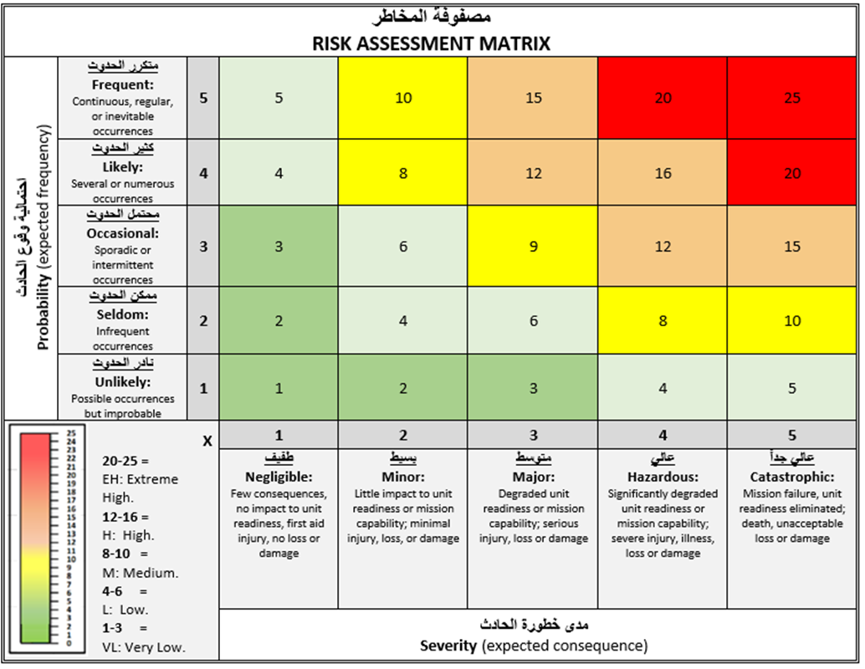
Once form is complete: Enter into Esnaad Safety Management System (SMS) permanent records.
Refer to the JAC ESMS Handbook for further guidance.

